|  |
| --- |
| Data Visualisation 2 Report |
| By Ethan Ho Wye Kit (32930267) |

|  |
| --- |
| Visualisation URL: |

# Domain

The domain chosen for this assignment is **Restaurants**, in particular Michelin Awards. The Michelin Star is an award given to restaurants that offer world class dining experiences.

# Why

The Michelin Star is a prestigious award granted to restaurants that are of or set world class standards in the culinary space. The Michelin Guide is a guide book annually published by the company of the same name. It contains an index of restaurants and hotels that have been awarded up to 3 stars, each increasing star representing a level of excellence in dining experience. The guide was initially published as an incentive for tourist to travel through driving, subsequently using their automobiles more. As of today, the guide book lists establishments ranging across 3 continents. Through visualisations, we can see the spatial distribution of these awarded restaurants spanning multiple continents. Observations such as which country or continent has the greatest number of stars, the most expensive restaurants etc. can be made. Using the complimentary data provided in the dataset, we can also see the distribution of types of awards handed out as well as the general price range of Michelin starred establishments globally.

# Who

This visualisation is designed for travellers and food-lovers as the visualisation displays a record of highly reputable restaurants internationally, allowing them to plan their destinations, budgets, and expectations.

# What

The dataset (Kaggle, 2023) consists of records of Michelin-awarded restaurants globally including price ranges, award received, cuisine and country and city of origin. The dataset was constructed using a web scraping tool, namely Goang (Ng, 2023). Restaurant details were scraped from the Michelin guide on Google Maps and transposed into a dataset.

# Why and How

The first two charts used the same idiom – dot map. The dot map is used to show the spatial distribution of the restaurants within an area. Both visualisations using point marks to indicate the location of the establishment. Colour channels were also used to display the type of award given to the restaurant by the Michelin inspectors. I chose to use different projections for each visualisation as I wanted to provide both an overview and a zoom and filter emphasis visualisation separately. Tooltips were then used to provide details in-demand. This all was done to abide by Schneiderman’s mantra (hampdatavisualization, 2016).

The overview map used an Equal Earth projection to display all the data points at once. I chose this projection as I wanted to display the entire world. The rotatable globe used an orthographic projection, which allowed it to be rotated and zoomed in upon, while preserving all the points.

The first bar chart is used to display the magnitude of restaurants per country. The second bar chart is used to display the magnitude of restaurants per award and per country (if selected). Both these charts utilise length to expressive the quantitative value and allocated one spatial region for each mark. Colour luminance is used for both charts to show the amounts for each category. In the first bar chart, a line mark was used to indicate the mean count of restaurants for all selected countries.

The last chart uses a donut chart idiom. The chart comprises of small multiples of the part-to-whole relationship between each type of Michelin award and its price ranges. An arc mark is used to showcase the magnitude of each price range within that award. Colour hues are used to differentiate between each price range.

# Design

## Layout

In terms of viewing path, I ensured that visualisations were placed in an order of importance. The main diagram (Figure 1) was placed on top of the rest of the visualisations. This also helped place the chart in the visual centre as all interactivity stems from that visualisation. The rest of the visualisations were placed at the bottom. I placed an emphasis on balance by allocated horizontal sections for each visualisation, grouping them together if I deemed appropriate. This ensured that the visualisations were distributed equally and symmetry was evident, as well as sufficient white space. Sightlines used can be seen in the image below (Figure 2).

## Colour

For this visualisation, colour hue was most used colour space. Colour is chosen intuitively for charts and text. For example, red is chosen for header as Formula One is synonymous with that colour as well as the colour being used to express values for red flags. When expressing different types of incidences in charts, colour was kept consistent for each category across different visualisations. This meant that the colours used in the top visualisation (Figure 3) matches the one below (Figure 5). In addition, the contrast on annotations were adjusted to ensure readability of the content (Figure 3).

## Figure-ground

In order to establish a visual hierarchy, I used font style and size. For example, headers were bolded and set to a larger size in contrast to normal text. In addition, important values were bolded within annotations to place more emphasis on them. A non-standardised typeface was given to the main title in order to separate it from the rest of the headers. Colour was also used to highlight certain words on the headers and text that was complimentary to the visualisation it labelled, such as safety cars and red flags words matching the colours allocated to them (Figure 5).

## Typography

For the title, a non-standard typography (Impact) was used. This typography was chosen as it complimented the topic of this visualisation when adjusted with the italics setting. For the rest of the text, standard Sans serif-like typefaces were chosen due to their monitor suitability and modernity. Text bolding was used appropriately within those text.

## Storytelling

As mentioned, the visualisations are placed in a vertical fashion as readers tend to read from top to bottom. Eye movement is also considered when determining the position of headers and text with their visualisations. For example, the text section is placed on the left side of the visualisation, granting the reader context before observing the visualisation (Figure 4). This uses the Gestalt principle of proximity in tandem.

Annotated charts are frequently used within this visualisation. Text providing context and insights can be found within diagrams (Figure 3) as well as next to them. The hierarchy is established in these annotations those text colour and styles, allowing for emphasis to be placed on certain sections.

# Bibliography

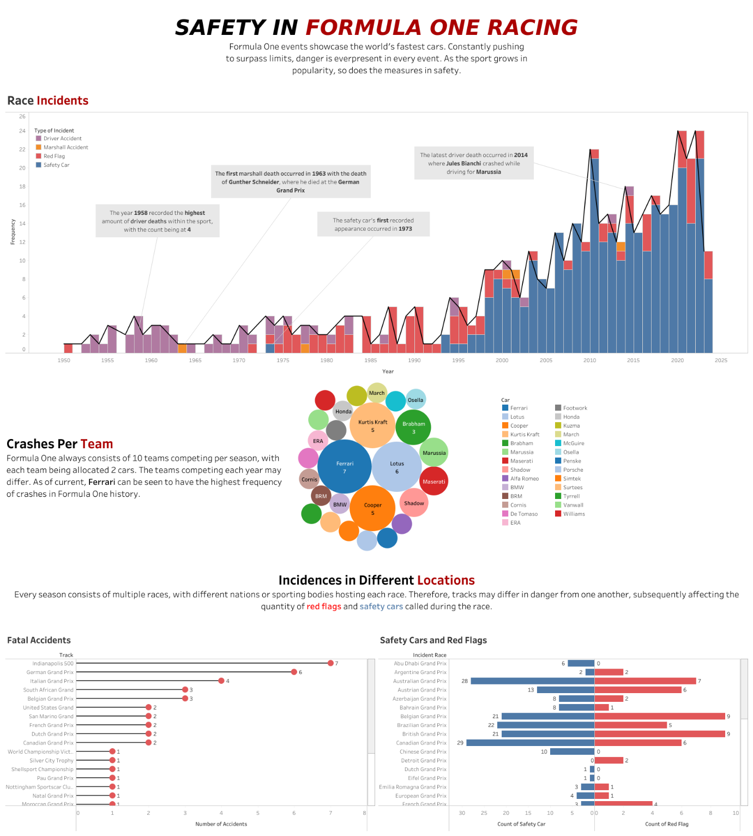

Figure 1: Dashboard View

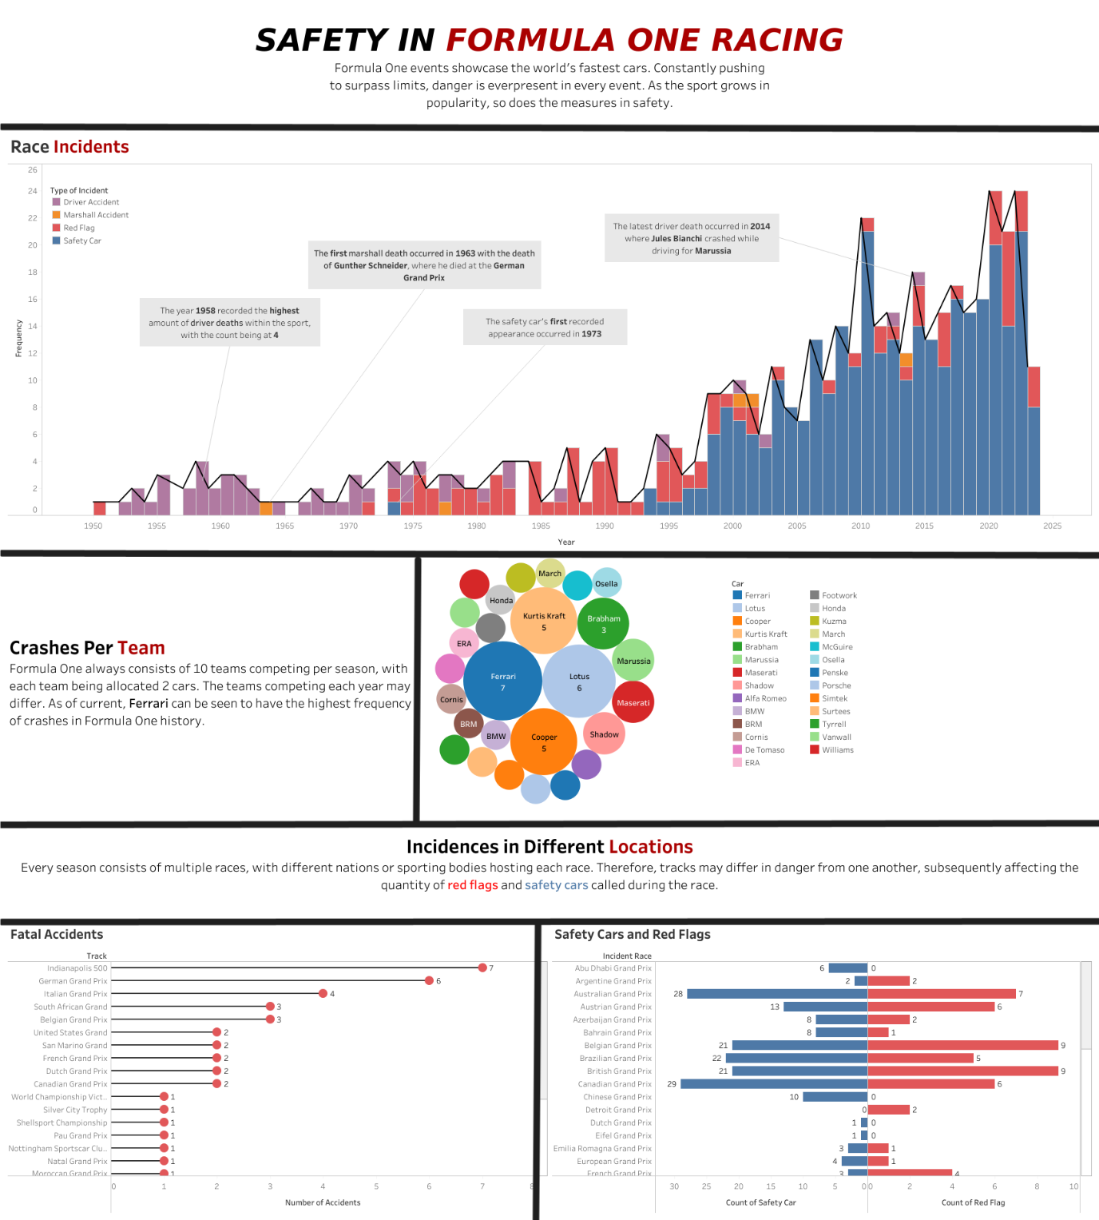

Figure 2: Sightlines in Dashboard

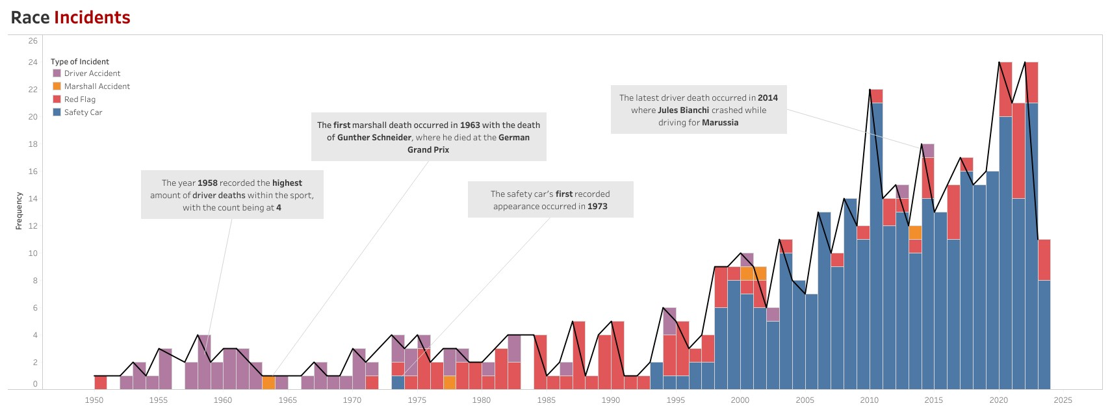

Figure 3: Race Incidents

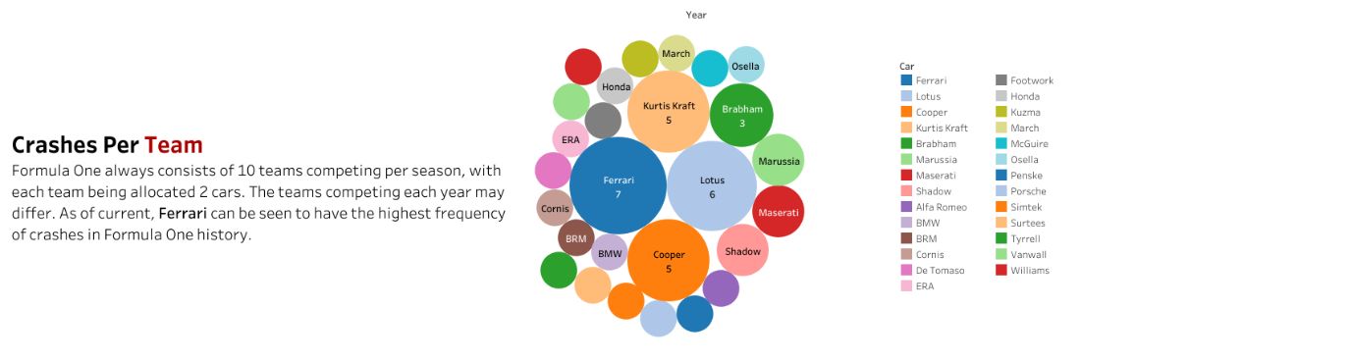

Figure 4: Crashes Per Team

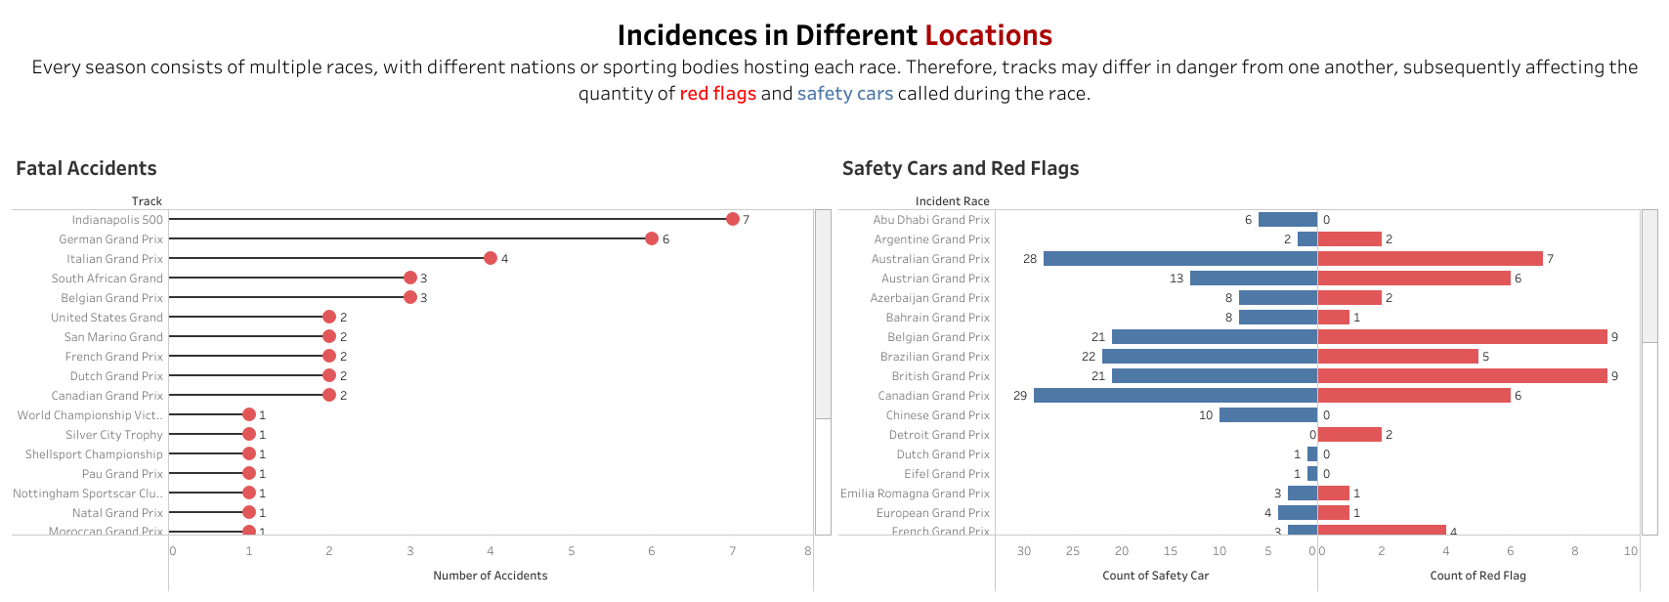

Figure 5: Incidences in Different Locations

# References

*Michelin Guide Restaurants*. (n.d.). Www.kaggle.com. <https://www.kaggle.com/datasets/ngshiheng/michelin-guide-restaurants-2021>

Ng, J. (2022, March 21). How I Scraped Michelin Guide Using Golang [Review of *How I Scraped Michelin Guide Using Golang*]. *How I Scraped Michelin Guide Using Golang*. <https://jerrynsh.com/how-i-scraped-michelin-guide-using-golang/>

hampdatavisualization. (2016, February 26). *Schneiderman’s Mantra*. Data Visualization. <https://hampdatavisualization.wordpress.com/2016/02/26/schneidermans-mantra/>

Trotman, J. (2023a). Retrieved from <https://www.kaggle.com/datasets/jtrotman/formula-1-race-events?select=fatal_accidents_drivers.csv>

*Safety car*. (2023, August 22). Wikipedia. <https://en.wikipedia.org/wiki/Safety_car#List_of_safety_car_deployments_in_Formula_One_races>

*List of red-flagged Formula One races*. (2022, March 4). Wikipedia. <https://en.wikipedia.org/wiki/List_of_red-flagged_Formula_One_races>

# Appendix

Contains 5 pages for the Five Design Sheet

## Page 1

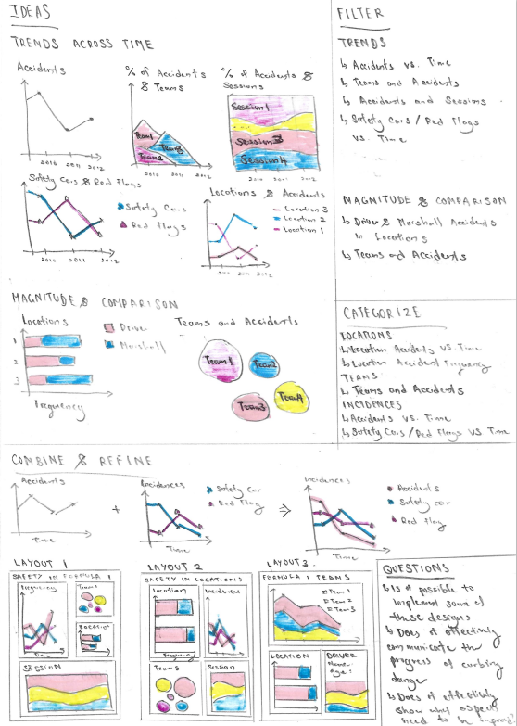

## Page 2

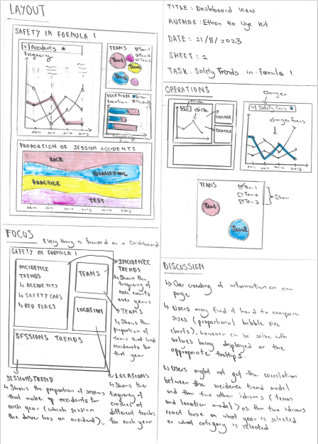

## Page 3

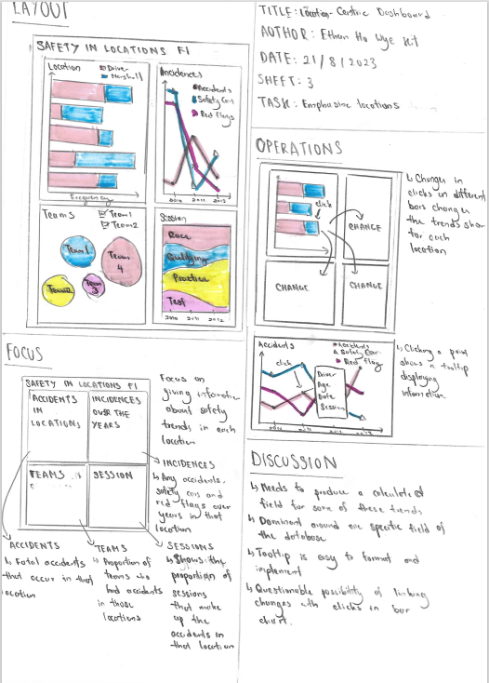

## Page 4

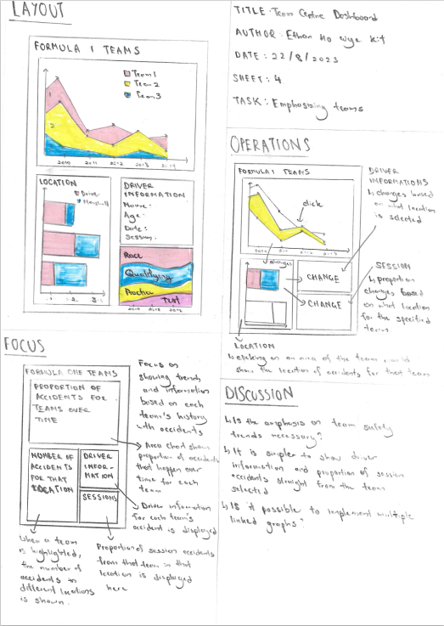

## Page 5

